SET 30 – MOBILE APP USAGE ANALYSIS
User_ID | Gender | Age | Screen_Time (hrs) | App_Usage_Count | Data_Used (GB) | Satisfaction | Usage_Date
U01 | Male | 20 | 4.5 | 18 | 2.4 | 3 | 2025-01-08
U02 | Female | 22 | 6.0 | 25 | 3.8 | 5 | 2025-01-08
U03 | Male | 19 | 3.2 | 12 | 1.6 | 3 | 2025-02-11
U04 | Female | 21 | 7.1 | 30 | 4.5 | 5 | 2025-02-11
U05 | Male | 23 | 2.8 | 10 | 1.2 | 2 | 2025-03-14
U06 | Female | 20 | 5.4 | 22 | 3.1 | 4 | 2025-03-14

Question 1: Histogram and Density Plot of Screen Time

Aim
To import Mobile_App_Usage.csv in R, create a histogram and density plot for Screen_Time with suitable colors and labels, and interpret the screen-time distribution.

R Code

# Create the dataset directly in R
mobile <- data.frame(
User_ID = c("U01", "U02", "U03", "U04", "U05", "U06"),
Screen_Time = c(4.5, 6.0, 3.2, 7.1, 2.8, 5.4)
)
# Create histogram
hist(mobile$Screen_Time,
probability = TRUE,
breaks = 5,
col = "lightblue",
border = "black",
main = "Distribution of Mobile App Screen Time",
xlab = "Screen Time (hours)",
ylab = "Density")
# Add density curve
lines(density(mobile$Screen_Time),
col = "red",
lwd = 2)
# Add marks for individual observations
rug(mobile$Screen_Time, col = "darkblue")

Output
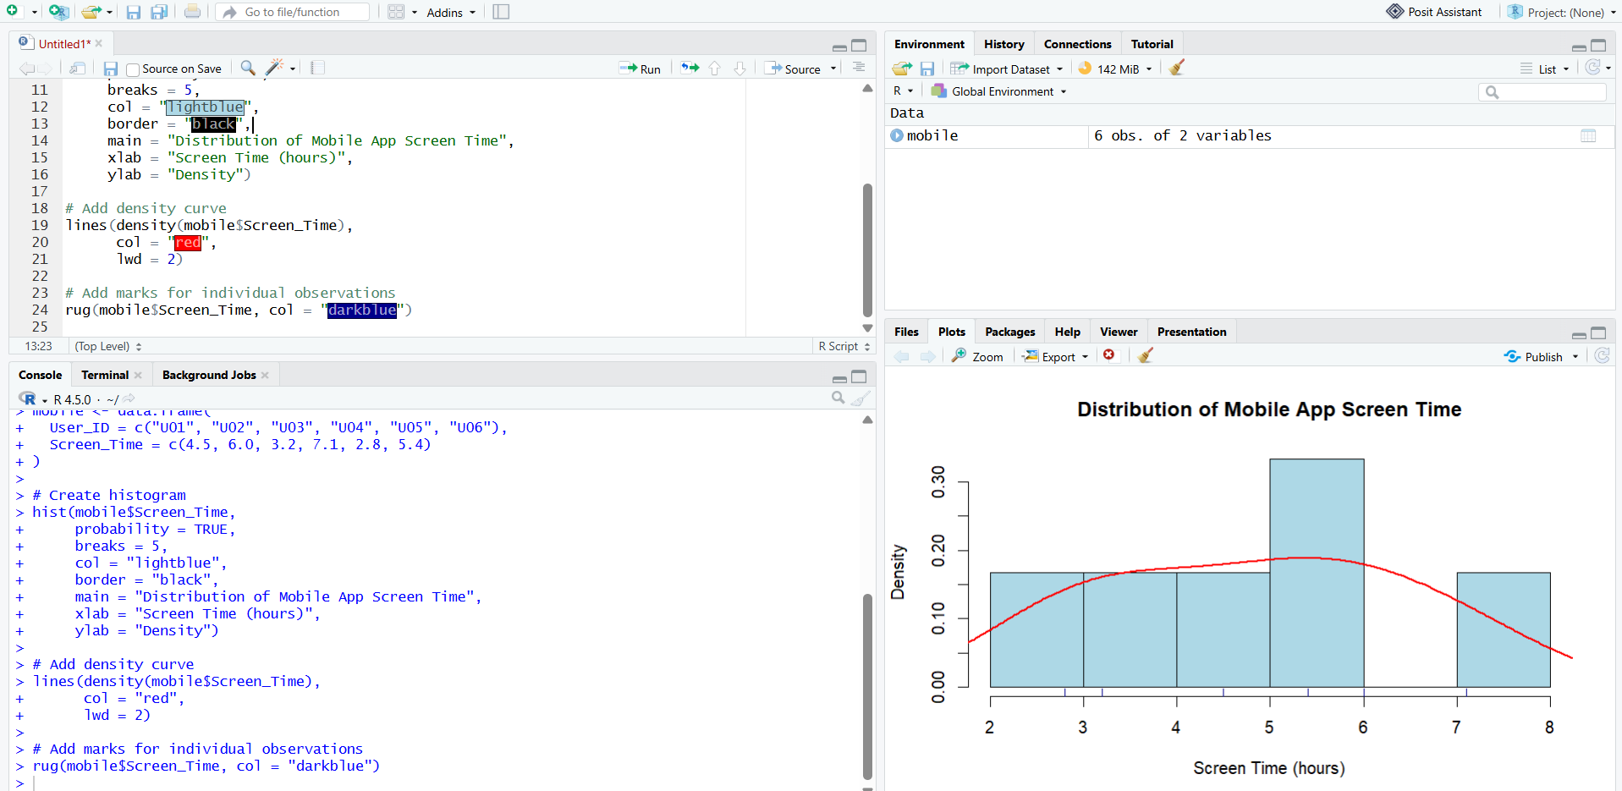

Question 2: Scatter Plot of Data Used and Screen Time

Aim
To create a scatter plot between Data_Used and Screen_Time in R, calculate the correlation, add a linear trend line and explain the relationship.

R Code

# Create the dataset directly in R
mobile <- data.frame(
User_ID = c("U01", "U02", "U03", "U04", "U05", "U06"),
Screen_Time = c(4.5, 6.0, 3.2, 7.1, 2.8, 5.4),
Data_Used = c(2.4, 3.8, 1.6, 4.5, 1.2, 3.1)
)
# Calculate correlation
cor_value <- cor(mobile$Data_Used, mobile$Screen_Time)
print(cor_value)
# Create scatter plot
plot(mobile$Data_Used, mobile$Screen_Time,
pch = 19,
col = "blue",
main = "Data Used vs Screen Time",
xlab = "Data Used (GB)",
ylab = "Screen Time (hours)")
# Add trend line
model <- lm(Screen_Time ~ Data_Used, data = mobile)
abline(model, col = "red", lwd = 2)
# Display correlation
cat("Correlation =", round(cor_value, 3), "\n")

Output
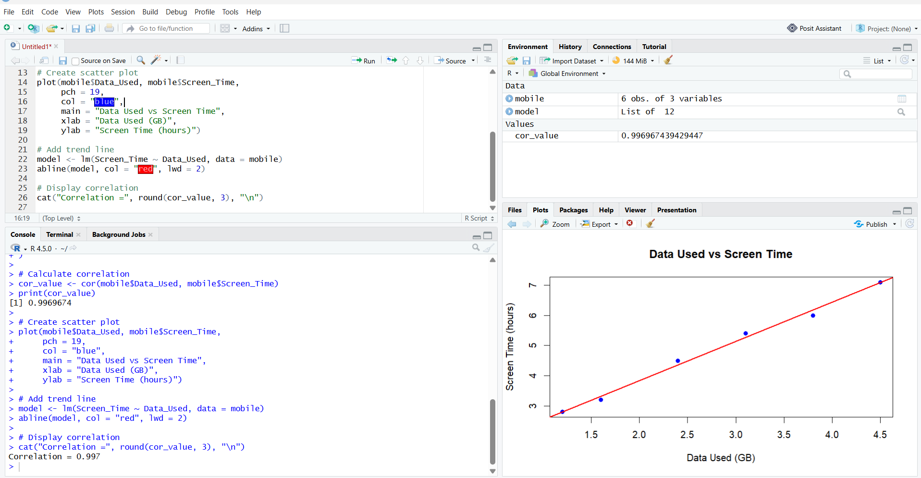

Question 3: Average Satisfaction by Gender

Aim
To calculate the average Satisfaction score for each Gender in R, display the averages in a bar chart, add value labels and interpret the pattern.

R Code

# Create the dataset directly in R
mobile <- data.frame(
Gender = c("Male", "Female", "Male",
"Female", "Male", "Female"),
Satisfaction = c(3, 5, 3, 5, 2, 4)
)
# Calculate average satisfaction by gender
avg_satisfaction <- aggregate(
Satisfaction ~ Gender,
data = mobile,
FUN = mean
)
# Display average values
print(avg_satisfaction
# Create bar chart
bar_positions <- barplot(
avg_satisfaction$Satisfaction,
names.arg = avg_satisfaction$Gender,
col = c("skyblue", "orange"),
ylim = c(0, 5.5),
main = "Average Satisfaction by Gender",
xlab = "Gender",
ylab = "Average Satisfaction (1-5)"
)
# Add value labels
text(
x = bar_positions,
y = avg_satisfaction$Satisfaction + 0.15,
labels = round(avg_satisfaction$Satisfaction, 2)
)

Output
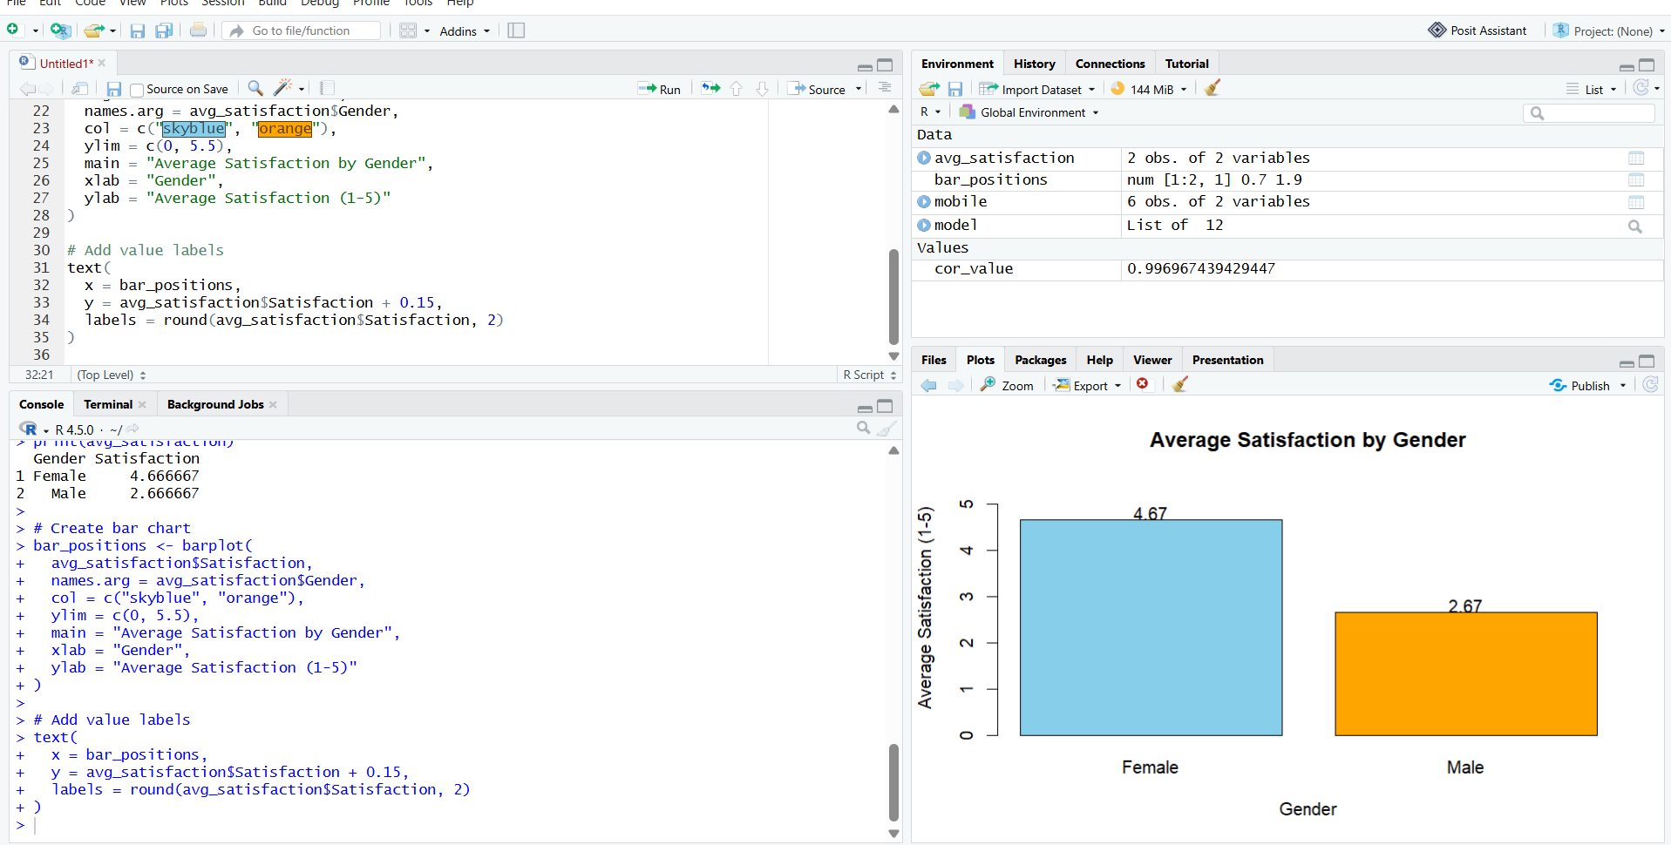

Question 4: Tableau Bubble Chart, Usage Trend and Mini Dashboard

Aim
To import Mobile_App_Usage.csv into Tableau, create a bubble chart with Screen_Time versus Data_Used, use Gender for color and App_Usage_Count for size, create a usage-trend line chart, add Gender and Usage_Date filters, and combine the charts into a mini dashboard.
Output:
